1. **Import NumPy as np**

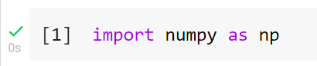

1. **Create an array of 10 zeros**

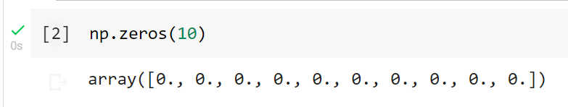

1. **Create an array of 10 ones**

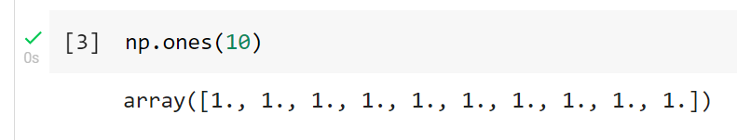

1. **Create an array of 10 fives**

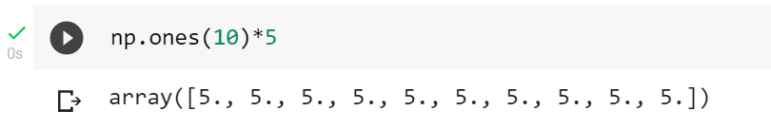

1. **Create an array of the integers from 10 to 50**

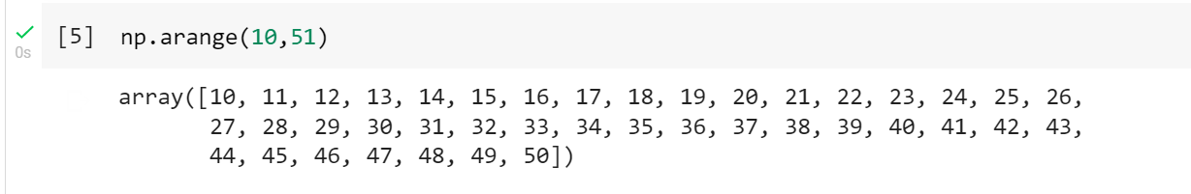

1. **Create an array of all the even integers from 10 to 50**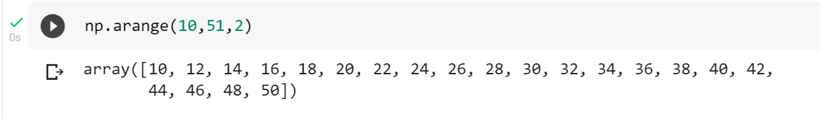
2. **Create a 3x3 matrix with values ranging from 0 to 8**

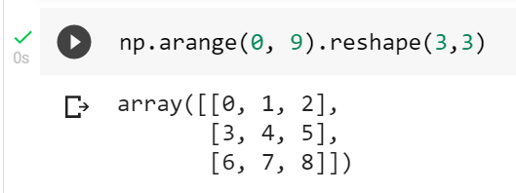

1. **Create a 3x3 identity matrix**

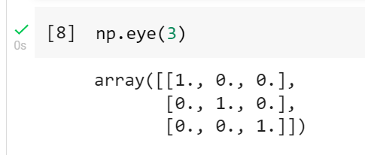

#### Use NumPy to generate a random number between 0 and 1

#### Use NumPy to generate an array of 25 random numbers sampled from a standard normal distribution

#### Create the following matrix:

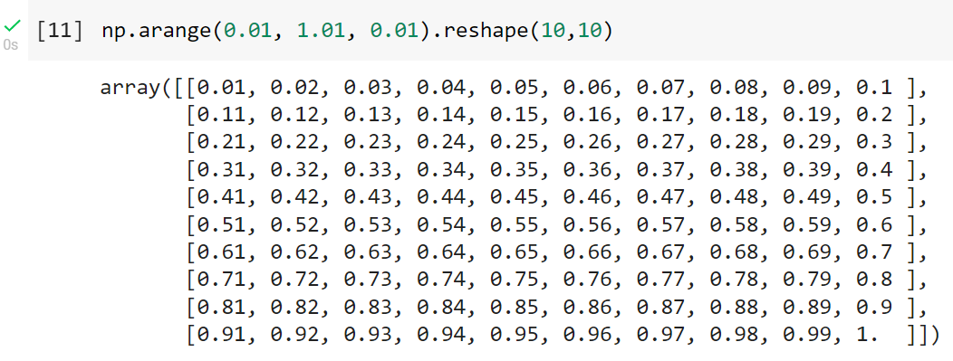

#### Create an array of 20 linearly spaced points between 0 and 1:

#### 

## **Numpy Indexing and Selection**

1. **Now you will be given a few matrices, and be asked to replicate the resulting matrix outputs:**

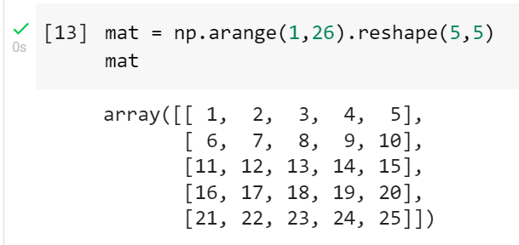

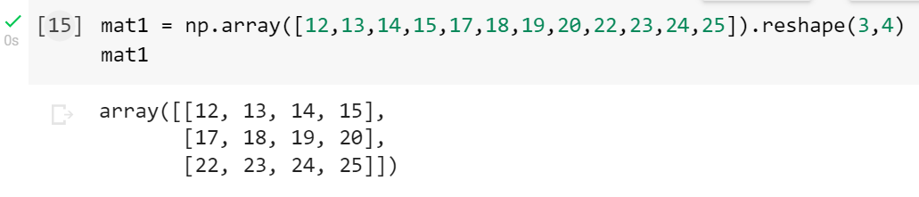

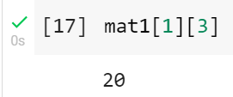

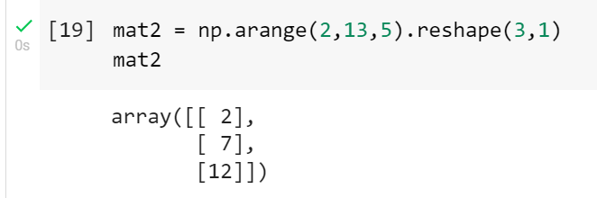

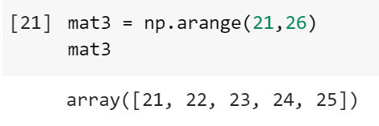

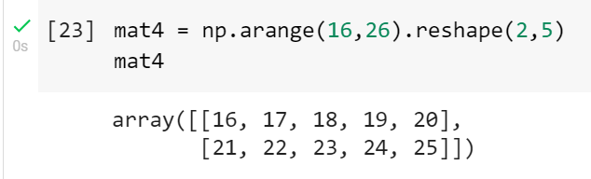

#### Get the sum of all the values in mat

#### 

#### Get the standard deviation of the values in mat

#### Get the sum of all the columns in mat

#### 

#### CONCLUSION:

#### From this practical, I have successfully learned about numpy library in python.